**Table 1**

**Add-on Basic Statistics**

|  |  |
| --- | --- |
| Variable | Description |
| Add-on Daily Download() | Number of user’s who download an add-on in a given day |
| Add-on Daily Users() | The daily users of add-on in the previous day, which is visible to consumers |
| Rating Valence Mean  () | This is discrete number of stars that show rate of the product out of 5. We recovered this information from historical data of rating, the same way Mozilla Firefox builds it. |
| Rating Variance () | This is variance of distribution of product rating shown to consumer. We recovered this from historical data on distribution of product ratings, the same way consumer observed dispersion of ratings. |
| New Version of add-on() | On Mozilla website it is an indicator variable that shows new version is issued, but we smooth it based on demand and release trend curve presented by Wiggins and Howison (2009)[1] and also based on consumer procrastination theory. |
| Mozilla Firefox daily Users  () | We recovered this information by multiplying Mozilla Firefox market share to the total number of internet host at given month. |
| Total number of add-ons create per day() | Cumulative number of add-ons created by the community of developers from inception of our data. |
| Google Chrome daily Users  () | We recovered this information by multiplying Google Chrome’s market share to the total number of internet host at given month. We use this variable to explain external market force. |
| Microsoft Internet Explorer (IE) daily Users () | We recovered this information by multiplying Microsoft Internet Explorer’s market share to the total number of internet host at given month. We use this variable to explain external market force. |
| Total number of monthly AMO Editor’s contribution() | In order for an add-on version to become public and readily available to all, it needs to be submitted for review by its author, and pass the review process. This process is called nomination[2]. AMO engages in four types of activities:[3] Full review nominations, Full review updates, preliminary reviews, response to info request. [4] Mozilla Firefox forum calls the sum of number of response of AMO to these incidences, nominations, total editor contributions, which we capture in this variable.[5] |
| Total length of the monthly AMO nomination queue() | After nomination, the add-on status page will indicate a status of “In Sandbox: Public Nomination”. This means the add-on is in the nomination review queue[6]. |
| Ask for money contribution  () | In the page of some add-ons there is a portion that suggests if a user has enjoyed the add-on; the developer asks that she help support its continued development by making small money contribution, with a button that user can click to contribute. |
| Meet the developer option  () | In the page of some add-ons there is a portion that suggests meeting of the developer, to know about why the add-on is created and what’s next for this add-on. By clicking on the link one can see the contact information of the developer and his profile. |
| Fully Free License () | This is an indicator variable specifying whether the license of an add-on is either BSD or MIT/X11 License. |
| Restricted Licenses () | This is an indicator variable specifying whether the license of an add-on is either GNU or Custom License. |
| Mozilla License () | This is an indicator variable specifying whether the license of an add-on is Mozilla License. |

**Table 2**

**Add-on Basic Statistics**

|  |  |  |  |  |
| --- | --- | --- | --- | --- |
|  | **Mean** | **SD** | **Min** | **Max** |
| Daily Downloads (K) | 7.641 | 18.502 | 11.79 | 283.44 |
| Daily Users (M) | 0.883 | 1.955 | 1.00E-06 | 16.97 |
| Rating Valence Mean | 4.275 | 0.499 | 1 | 5 |
| Rating Variance | 1.46 | 0.76 | 0.48 | 4.2 |
| New Version of add-on | 0.015 | 0.123 | 0 | 1 |
| Length of time series | 1321.9 | 456.6 | 260 | 1686 |

**Table 3**

**Add-on Categories Basic Statistics**

|  |  |
| --- | --- |
| Appearance | 9 (17%) |
| Bookmarks | 3 (6%) |
| Download Management | 3 (6%) |
| Photo and Multimedia | 9 (17%) |
| Game and Entertainment | 3 (6%) |
| Privacy and Security | 6 (12%) |
| Language Support | 7 (13%) |
| Alerts Updates | 6 (12%) |
| Web Development | 13 (25%) |

**Table 4**

**Platform Basic Statistics**

|  |  |  |  |  |
| --- | --- | --- | --- | --- |
|  | **Mean** | **SD** | **Min** | **Max** |
| Mozilla Firefox daily Users (M) | 229 | 16 | 185 | 262 |
| Total number of add-ons create per day | 128 | 192 | 4 | 2,418 |
| Google Chrome daily Users (M) | 189 | 119 | 20 | 432 |
| Microsoft Internet Explorer (IE) daily Users (M) | 354 | 47 | 240 | 437 |
| Total number of monthly AMO Editor’s contribution | 1,444 | 442 | 794 | 2,620 |
| Total length of the monthly AMO nomination queue | 362 | 220 | 80 | 949 |

**Table 5**

**License Description[7]**

|  |  |  |  |  |  |  |
| --- | --- | --- | --- | --- | --- | --- |
| **Item** | **BSD** | **MIT/X11** | **Mozilla** | **GNU** | **Custom** | |
| Provides copyright protection | TRUE | TRUE | TRUE | TRUE | TRUE |
| Can be used in commercial applications | TRUE | TRUE | TRUE | TRUE | FALSE |
| Bug fixes / extensions must be released to the public domain | FALSE | FALSE | TRUE | TRUE | TRUE |
| Provides an explicit patent license | FALSE | FALSE | TRUE | FALSE | FALSE |
| Can be used in proprietary (closed source) applications | TRUE | TRUE | TRUE | FALSE | FALSE |

**Table 6**

**Descriptive Statistics of Licenses and Incentives**

|  |  |  |
| --- | --- | --- |
| **Item** | **Type** | **Frequency** |
| License | Fully free (MIT/X11,BSD) | 5 |
|  | Restricted (GNU, Custom) | 41 |
|  | Mozilla | 2 |
| Incentive | Contribute | 25 |
|  | Meet Developer | 10 |

**Table 7**

**MODEL COMPARISON**

|  |  |  |  |  |
| --- | --- | --- | --- | --- |
| **Model** | **Description** | **DIC** |  |  |
| 1 | No Churn | 393,181,425 | 196,887,137 | 296,425 |
| 2 | No Version Carry Over | 393,249,002 | 196,921,381 | 296,881 |
| 3 | No AMO effect on platform | 393,258,460 | 196,926,790 | 297,560 |
| 4 | Interaction model | 393,224,624 | 196,921,662 | 309,350 |
| 5 | Unexplained internal market force of add-ons | 393,183,354 | 196,889,620 | 297,942 |
| 6 | Unexplained external market force of add-ons | 393,229,107 | 196,907,050 | 292,496 |
| 7 | Unexplained churn | 393,265,094 | 196,298,559 | 297,309 |
| 8 | No cumulative effect of add-on creation on platform | 393,220,649 | 196,903,764 | 293,439 |
| 9 | Unexplained relevance factor | 393,338,158 | 196,971,387 | 302,309 |
| 10 | Proposed Model | 393,029,826 | 196,694,177 | 179,264 |

**Table 8**

**Performance of the Proposed Model for Four Sample Add-ons and Platform**

|  |  |  |
| --- | --- | --- |
| **Description** | **MAD** | **MSE** |
| Firefox Platform | 1.20e-04 | 2.04e-05 |
| Auto-Pager Add-on | 0.0016 | 4.71e-06 |
| Google Translator for Firefox Add-on | 0.0012 | 3.34e-06 |
| Ad-block Plus Add-on | 0.0049 | 3.97e-05 |
| Stealthy Add-on | 0.0032 | 1.32e-05 |

**Table 9**

**PARAMETER ESTIMATES: PLATFORM**

|  |  |  |  |  |
| --- | --- | --- | --- | --- |
|  | **Estimate** | **Std. Dev.** | **2.5th** | **97.5th** |
| Market Size[8]: |  |  |  |  |
| Intercept of Market size | 1.54E-02 | 1.52E-06 | 1.54E-02 | 1.54E-02 |
| Total Add-ons Created | 3.60E-02 | 1.51E-06 | 3.60E-02 | 3.60E-02 |
| External Market Force: |  |  |  |  |
| Unobserved external Market Force | 1.76E-03 | 1.52E-06 | 1.76E-03 | 1.76E-03 |
| Google Chrome competitor | -4.91E-05 | 1.51E-06 | -5.17E-05 | -4.73E-05 |
| Microsoft Internet Explorer competitor | -5.66E-04 | 1.52E-06 | -5.68E-04 | -5.64E-04 |
| AMO Total number of contributions | 3.42E-05 | 1.51E-06 | 3.16E-05 | 3.61E-05 |
| AMO Length of the Queue of nominations | 3.52E-05 | 1.51E-06 | 3.26E-05 | 3.70E-05 |
| Internal Market Force: |  |  |  |  |
| Unobserved Internal Market Force | 1.27E-08 | 9.02E-09 | -2.03E-09 | 2.77E-08 |
| Variances: |  |  |  |  |
| Observation Equation | 1.44E-02 | 4.30E-03 | 8.52E-03 | 2.30E-02 |
| State Equation | 1.12E-01 | 8.35E-03 | 9.75E-02 | 1.25E-01 |

**Table 10**

**PARAMETER ESTIMATES: ADD-ONS**

|  |  |  |  |  |
| --- | --- | --- | --- | --- |
|  | **Estimate** | **Std. Dev.** | **2.5th** | **97.5th** |
| Relevance factor | 0.0142 | 0.0019 | 0.0104 | 0.0179 |
| Churn factor | 0.0174 | 0.0021 | 0.0132 | 0.0215 |
| External Market Force: |  |  |  |  |
| Unobserved | 0.0087 | 0.0018 | 0.0051 | 0.0123 |
| Add-on New Version | 0.0047 | 0.0011 | 0.0026 | 0.0067 |
| Platform New Version | 0.0059 | 0.0012 | 0.0035 | 0.0083 |
| Internal Market Force: |  |  |  |  |
| Unobserved | 0.0057 | 0.0014 | 0.0030 | 0.0085 |
| Rating Variance | 0.0131 | 0.0018 | 0.0096 | 0.0167 |
| Observational Learning | 0.0054 | 0.0016 | 0.0022 | 0.0086 |
| Rating valence mean | 0.0043 | 0.0014 | 0.0016 | 0.0070 |
| Variance: |  |  |  |  |
| Observation Equation | 0.0002 | 1.56E-05 | 0.0002 | 0.0002 |
| State Equation | 0.0002 | 1.74E-05 | 0.0002 | 0.0003 |

**Table 11**

**PARAMETER HETEROGENEITY**

|  |  |  |  |  |  |
| --- | --- | --- | --- | --- | --- |
|  |  | **Estimate** | **STD** | **2.5th** | **97.5th** |
| Relevance factor | Intercept | 0.014 | 0.007 | 0.002 | 0.026 |
|  | Ask for money contribution | 0.010 | 0.016 | -0.017 | 0.038 |
|  | Meet the developer option | -0.003 | 0.020 | -0.037 | 0.030 |
|  | Fully Free License | 0.001 | 0.034 | -0.056 | 0.057 |
|  | Restricted Licenses | 0.006 | 0.027 | -0.039 | 0.051 |
|  | Mozilla License | -0.001 | 0.046 | -0.076 | 0.073 |
| Churn factor | Intercept | 0.014 | 0.007 | 0.003 | 0.026 |
|  | Ask for money contribution | 0.010 | 0.016 | -0.017 | 0.037 |
|  | Meet the developer option | -0.003 | 0.021 | -0.037 | 0.032 |
|  | Fully Free License | 0.001 | 0.034 | -0.055 | 0.056 |
|  | Restricted Licenses | 0.007 | 0.026 | -0.037 | 0.051 |
|  | Mozilla License | 0.000 | 0.045 | -0.073 | 0.073 |
| External Market Force |  |  |  |  |  |
| Unobserved | Intercept | 0.014 | 0.007 | 0.002 | 0.025 |
|  | Ask for money contribution | 0.011 | 0.016 | -0.016 | 0.038 |
|  | Meet the developer option | -0.003 | 0.020 | -0.036 | 0.031 |
|  | Fully Free License | 0.001 | 0.034 | -0.055 | 0.056 |
|  | Restricted Licenses | 0.007 | 0.027 | -0.036 | 0.051 |
|  | Mozilla License | -0.001 | 0.045 | -0.075 | 0.072 |
| Add-on New Version | Intercept | 0.009 | 0.007 | -0.003 | 0.021 |
|  | Ask for money contribution | 0.000 | 0.017 | -0.028 | 0.027 |
|  | Meet the developer option | 0.009 | 0.022 | -0.027 | 0.045 |
|  | Fully Free License | -0.019 | 0.036 | -0.077 | 0.039 |
|  | Restricted Licenses | -0.005 | 0.028 | -0.051 | 0.041 |
|  | Mozilla License | -0.013 | 0.047 | -0.091 | 0.063 |
| Platform New Version | Intercept | 0.005 | 0.007 | -0.007 | 0.016 |
|  | Ask for money contribution | -0.001 | 0.017 | -0.030 | 0.028 |
|  | Meet the developer option | 0.014 | 0.023 | -0.023 | 0.051 |
|  | Fully Free License | -0.014 | 0.036 | -0.074 | 0.045 |
|  | Restricted Licenses | -0.004 | 0.028 | -0.050 | 0.043 |
|  | Mozilla License | 0.000 | 0.048 | -0.080 | 0.078 |
| Internal Market Force |  |  |  |  |  |
| Unobserved | Intercept | 0.014 | 0.007 | 0.003 | 0.026 |
|  | Fully Free License | -0.001 | 0.034 | -0.058 | 0.056 |
|  | Restricted Licenses | 0.006 | 0.027 | -0.039 | 0.050 |
|  | Mozilla License | -0.002 | 0.045 | -0.077 | 0.072 |
|  | Ask for money contribution | 0.000 | 0.029 | -0.048 | 0.047 |
|  | Meet the developer option | -0.003 | 0.021 | -0.037 | 0.032 |
|  | Asked contribution amount | 0.002 | 0.004 | -0.004 | 0.007 |
| Rating Variance | Intercept | 0.009 | 0.007 | -0.004 | 0.021 |
|  | Fully Free License | -0.018 | 0.036 | -0.076 | 0.040 |
|  | Restricted Licenses | -0.005 | 0.028 | -0.051 | 0.042 |
|  | Mozilla License | -0.014 | 0.046 | -0.091 | 0.062 |
|  | Ask for money contribution | 0.001 | 0.029 | -0.048 | 0.049 |
|  | Meet the developer option | 0.009 | 0.022 | -0.026 | 0.045 |
|  | Asked contribution amount | 0.000 | 0.004 | -0.006 | 0.006 |
| Observational Learning | Intercept | 0.005 | 0.007 | -0.007 | 0.017 |
|  | Fully Free License | -0.015 | 0.037 | -0.076 | 0.046 |
|  | Restricted Licenses | -0.004 | 0.029 | -0.051 | 0.043 |
|  | Mozilla License | -0.003 | 0.048 | -0.081 | 0.076 |
|  | Ask for money contribution | -0.003 | 0.029 | -0.051 | 0.046 |
|  | Meet the developer option | 0.013 | 0.022 | -0.024 | 0.049 |
|  | Asked contribution amount | 0.000 | 0.004 | -0.006 | 0.006 |
| Rating mean | Intercept | 0.006 | 0.007 | -0.006 | 0.018 |
|  | Fully Free License | -0.010 | 0.036 | -0.069 | 0.049 |
|  | Restricted Licenses | -0.003 | 0.029 | -0.050 | 0.044 |
|  | Mozilla License | 0.021 | 0.048 | -0.058 | 0.100 |
|  | Ask for money contribution | -0.001 | 0.029 | -0.050 | 0.048 |
|  | Meet the developer option | 0.010 | 0.023 | -0.028 | 0.048 |
|  | Asked contribution amount | 0.000 | 0.004 | -0.006 | 0.006 |

**Figure 1**

**Mozilla Community Structure**

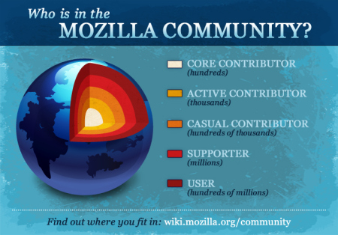

**Figure 2**

**Box and Arrow Representation of the Model**

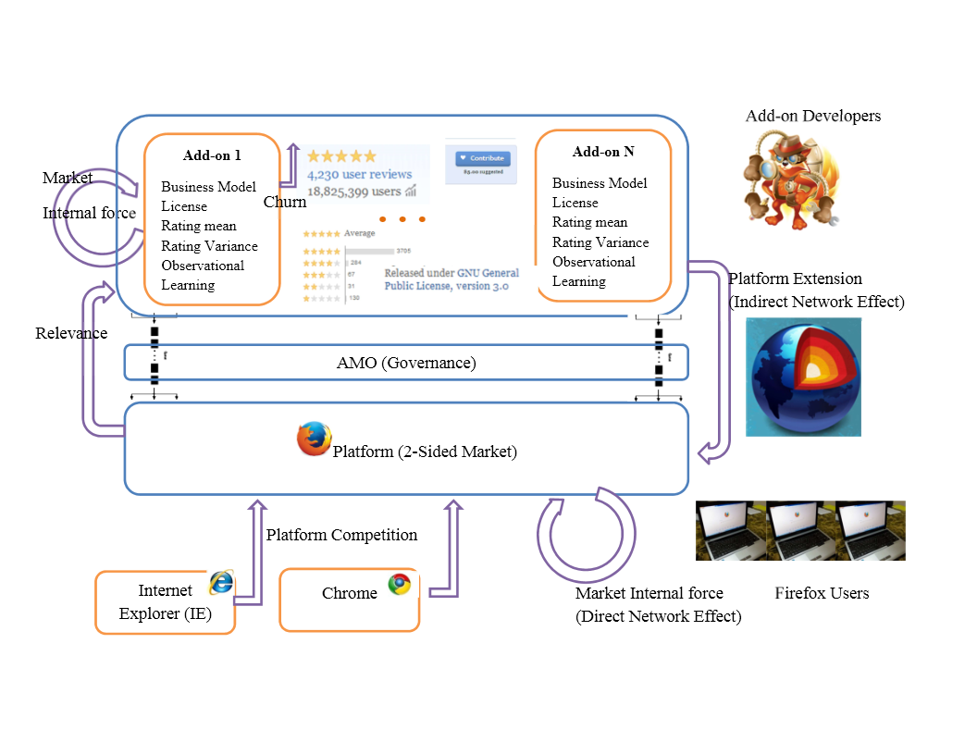

**Figure 3**

**Platform Diffusion Data**

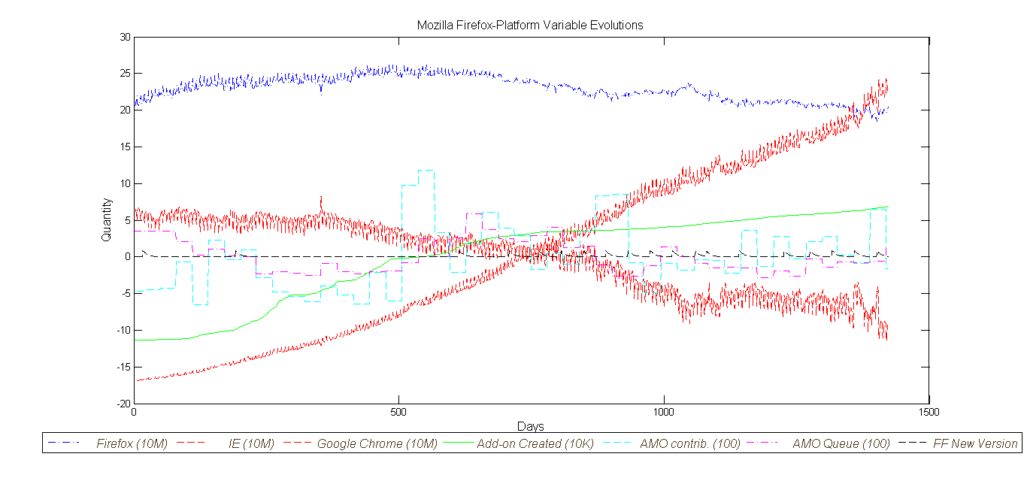

**Figure 4**

**Add-on Daily Downloads**

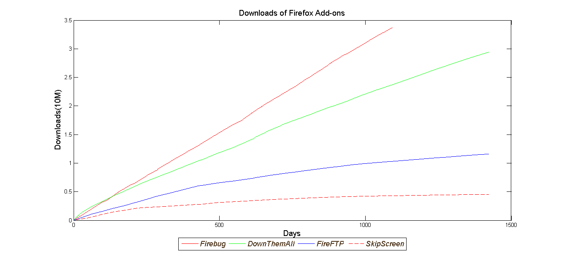

**Figure 4**

**Add-on Daily New Version**

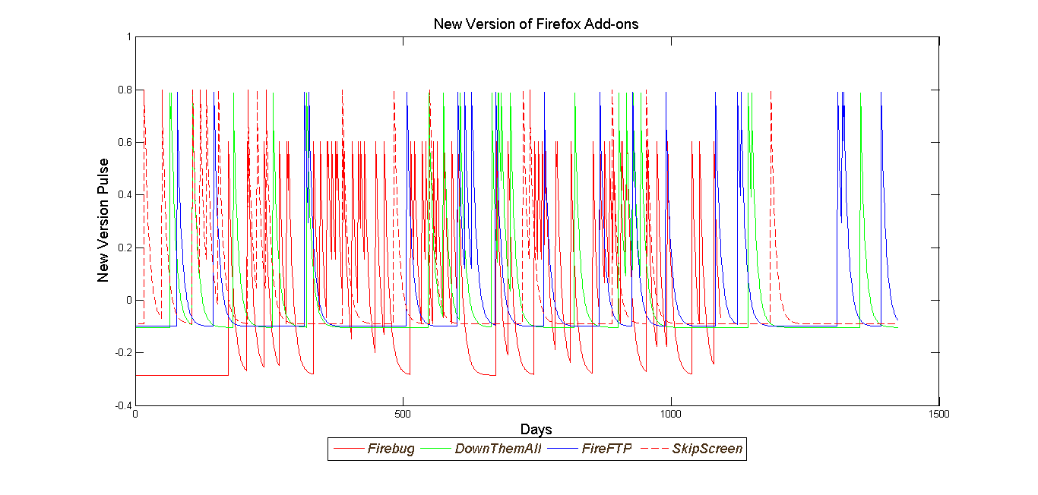

**Figure 4**

**Add-on Daily Variance of Rating**

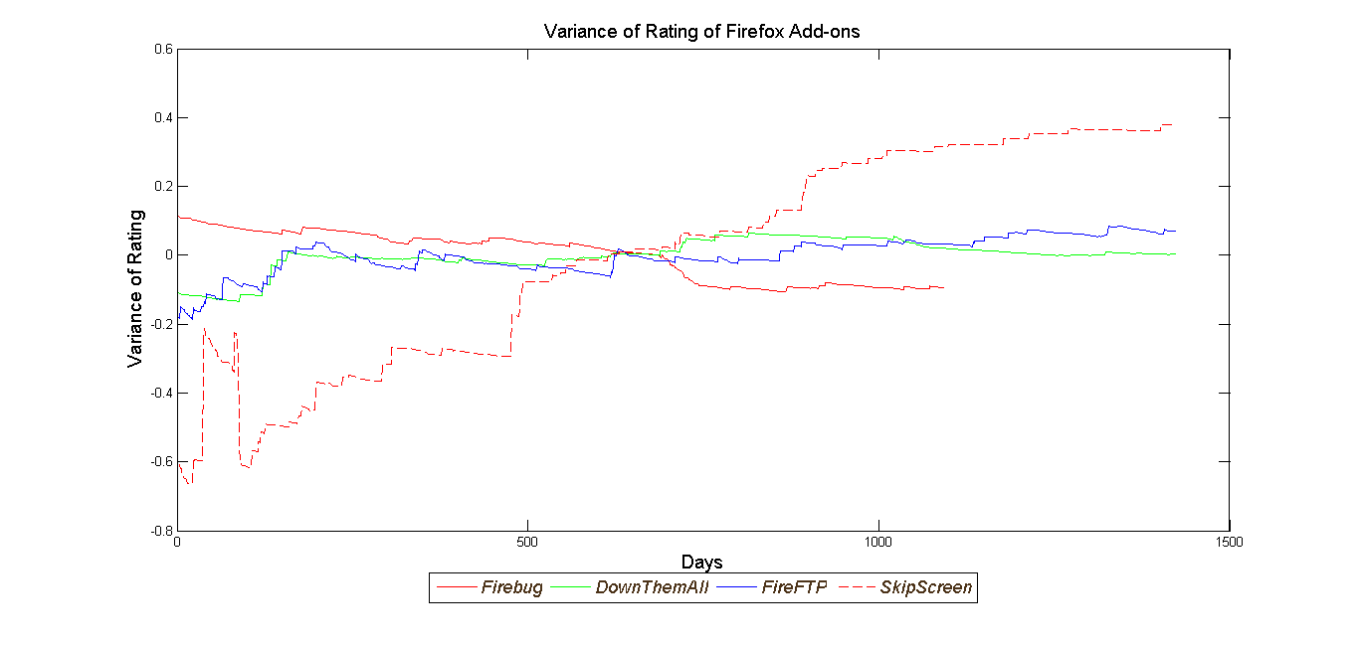

**Figure 4**

**Add-on Daily Users**

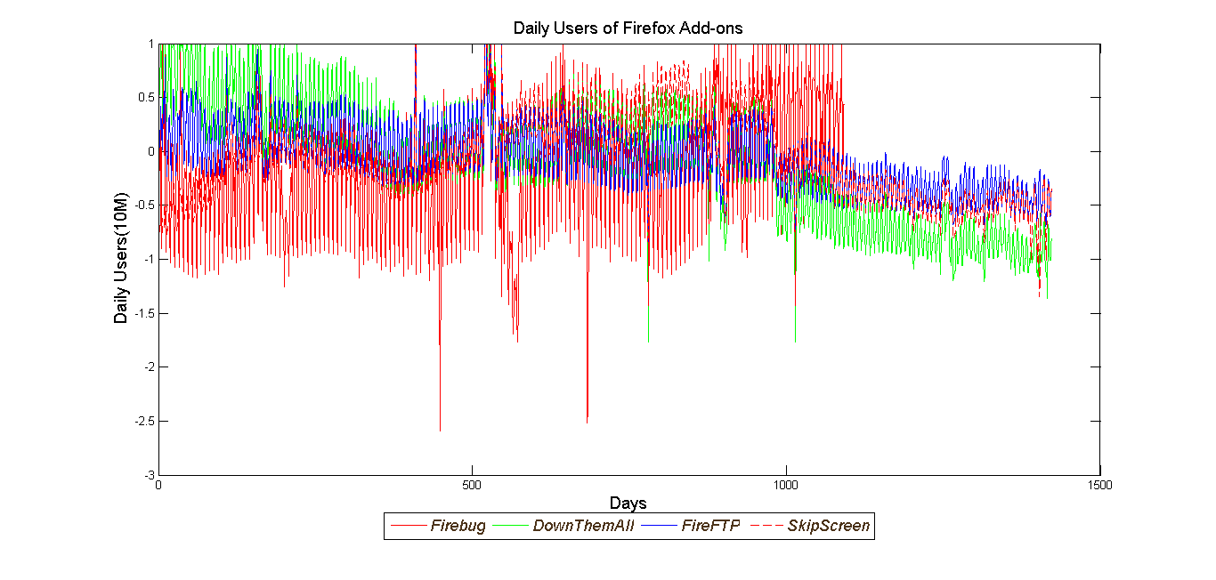

**Figure 4**

**One-Step Ahead Forecast of Four Sample Add-on’s Cumulative Downloads**

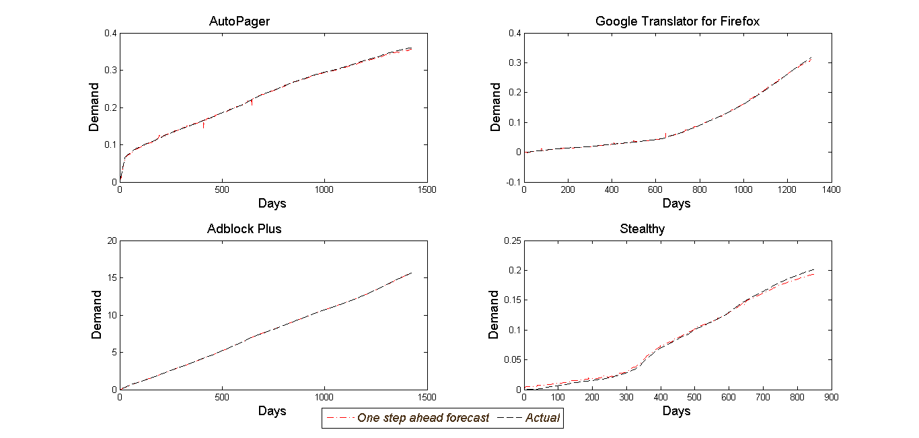

**Figure 5**

**One-Step Ahead Forecast of Firefox Platform Daily Users**

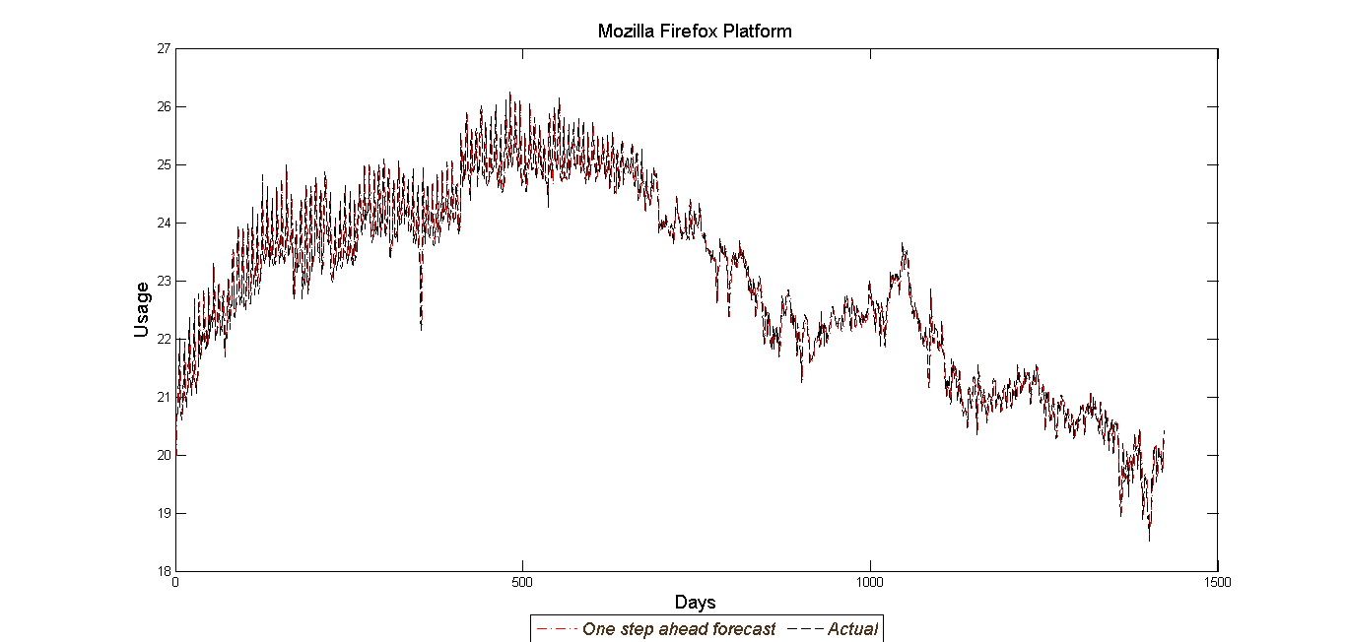

**Figure 6**

**Histogram of Parameter Estimate Across Add-ons**

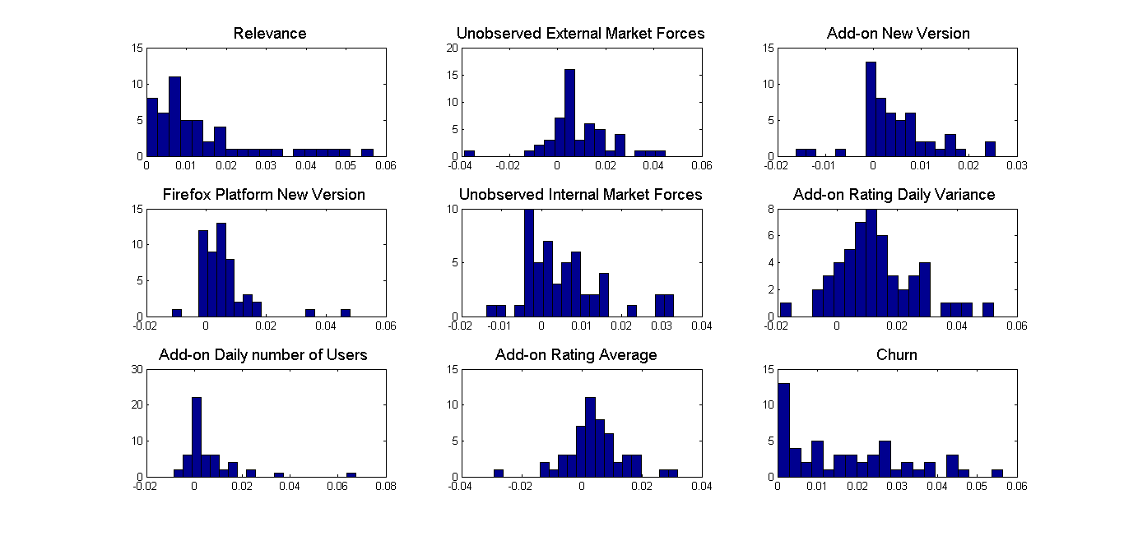

1. Wiggins, Andrea, James Howison, and Kevin Crowston. "Heartbeat: measuring active user base and potential user interest in FLOSS projects." *Open Source Ecosystems: Diverse Communities Interacting*. Springer Berlin Heidelberg, 2009. 94-104.
2. https://blog.mozilla.org/addons/2010/02/15/the-add-on-review-process-and-you/
3. https://blog.mozilla.org/addons/2011/02/04/overview-amo-review-process/
4. When someone submits a new add-on, it will have to choose between 2 review tracks: Full Review and Preliminary review; the first one checks whether the add-on is safe to use, respects user’s privacy and choice, doesn’t conflict with other add-ons or break existing Firefox features, is easy to use, and is worth publishing to a general audience. The second one, only requires add-on to be safe to use. Add-on with preliminary review approval appear on the site as Experimental, cant’ be featured and get lower search ranking. If an add-on approved in the preliminary review track, it can be nominated to the Full Review track after a 10 day waiting period.
5. https://forums.mozilla.org/addons/viewtopic.php?f=21&t=14313
6. https://blog.mozilla.org/addons/2010/02/15/the-add-on-review-process-and-you/
7. http://www.codeproject.com/info/Licenses.aspx
8. Market size is variable with time according to number of new add-ons 